**IT24103879**

**Sandeepa.W.M.R**

**IT2120 - Probability and Statistics – Lab Sheet 08**

**Exercise**

01)

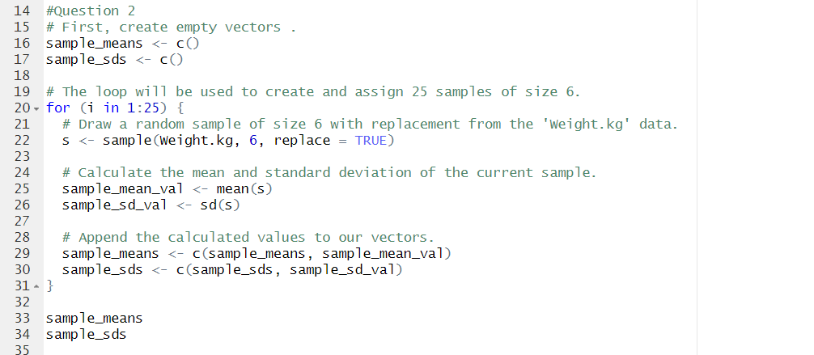02)

03)

